Movement Task Instructions

You will view a series of short videos of movements. At level 1, each trial will contain 1 movement. At level 2, each trial will contain 2 movements, and so forth. Once the series of videos has ended, your job is to replicate all of the movements shown on the trial for the experimenter observing you. Please replicate the movements with as much accurate detail as possible, including starting and ending positions, and in the order that they were shown. You should mirror the movements of the person in the video (i.e. when she uses her left arm, you use your right arm). Be sure to make eye contact with the experimenter before you begin. The experimenter will evaluate your performance and tell you when to go on to the next trial.

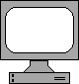
Get Ready
The ready screen signals that the trial will start.
First produce the starting position
Reproduce the movement with as much detail and accuracy as possible
Finish with the ending position
Reproduce the movements by mirroring the person in the video. Be as accurate and precise as possible

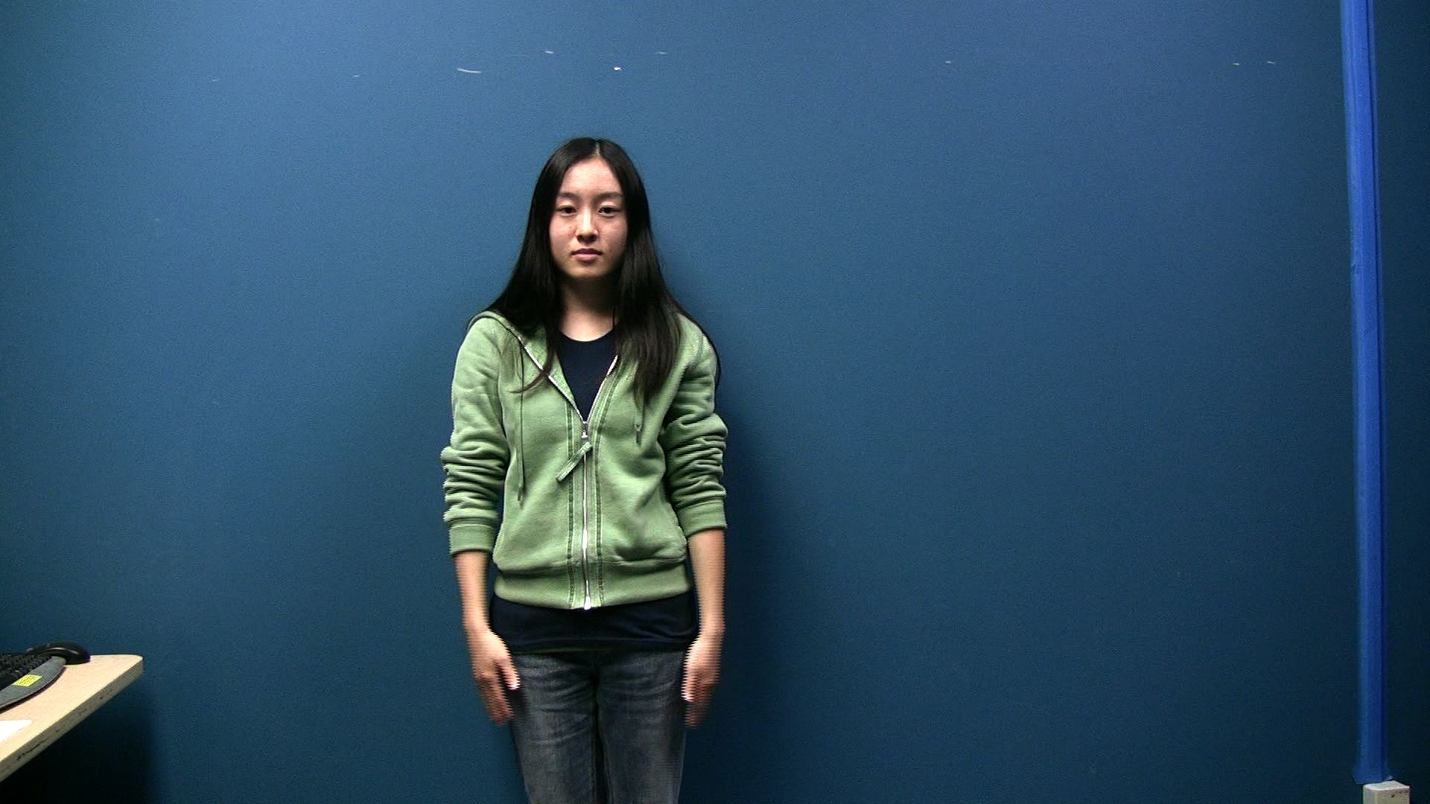
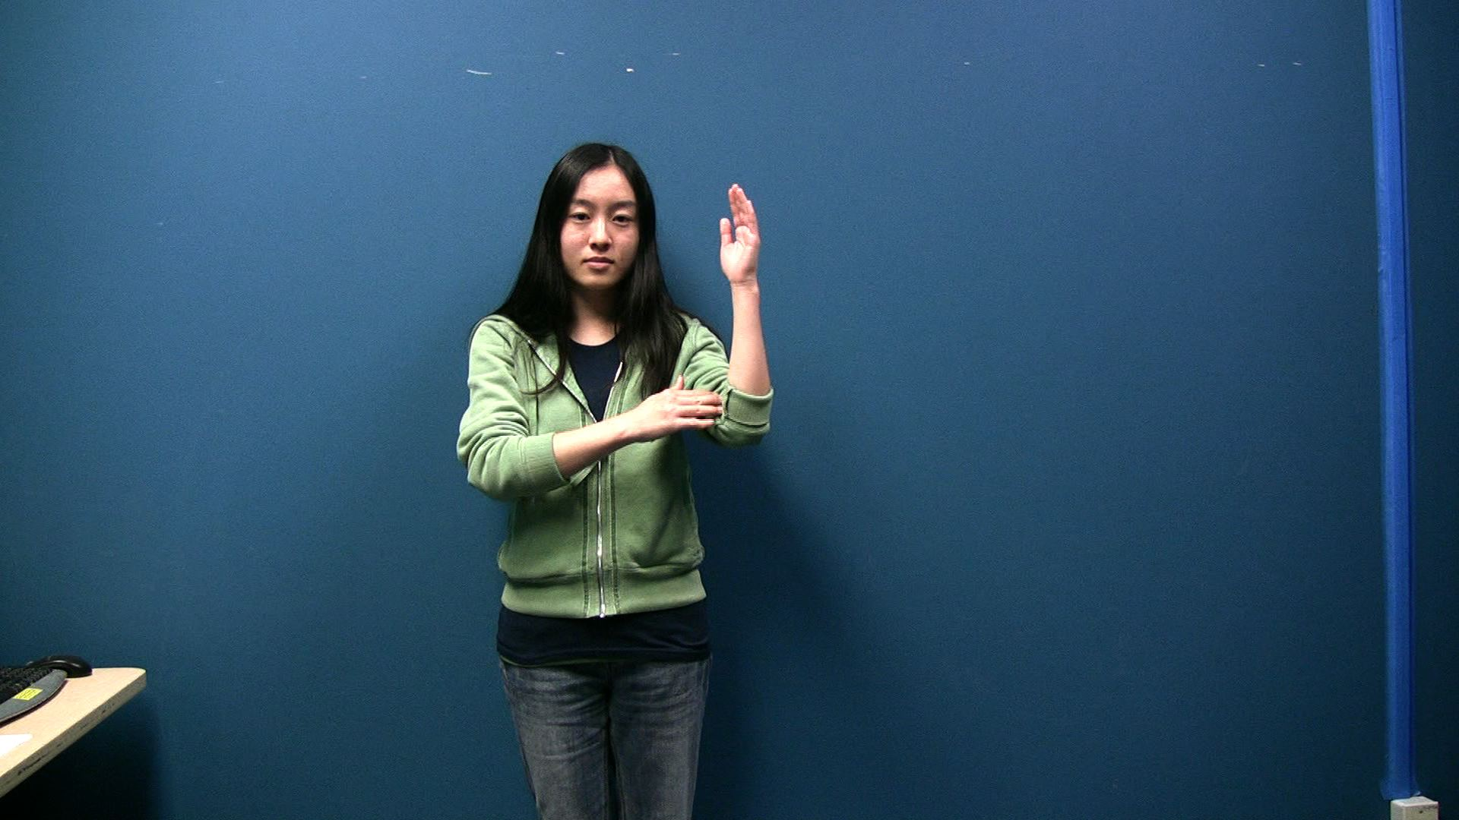
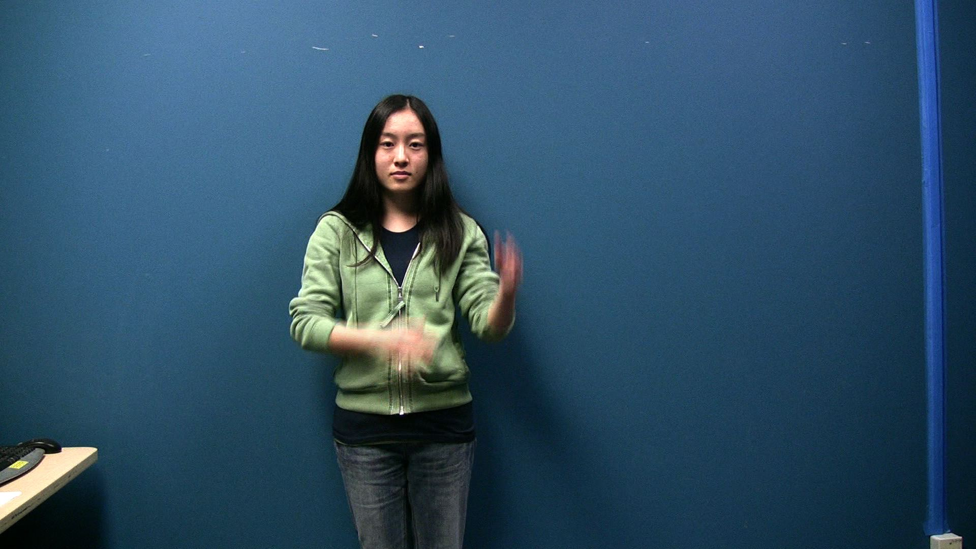
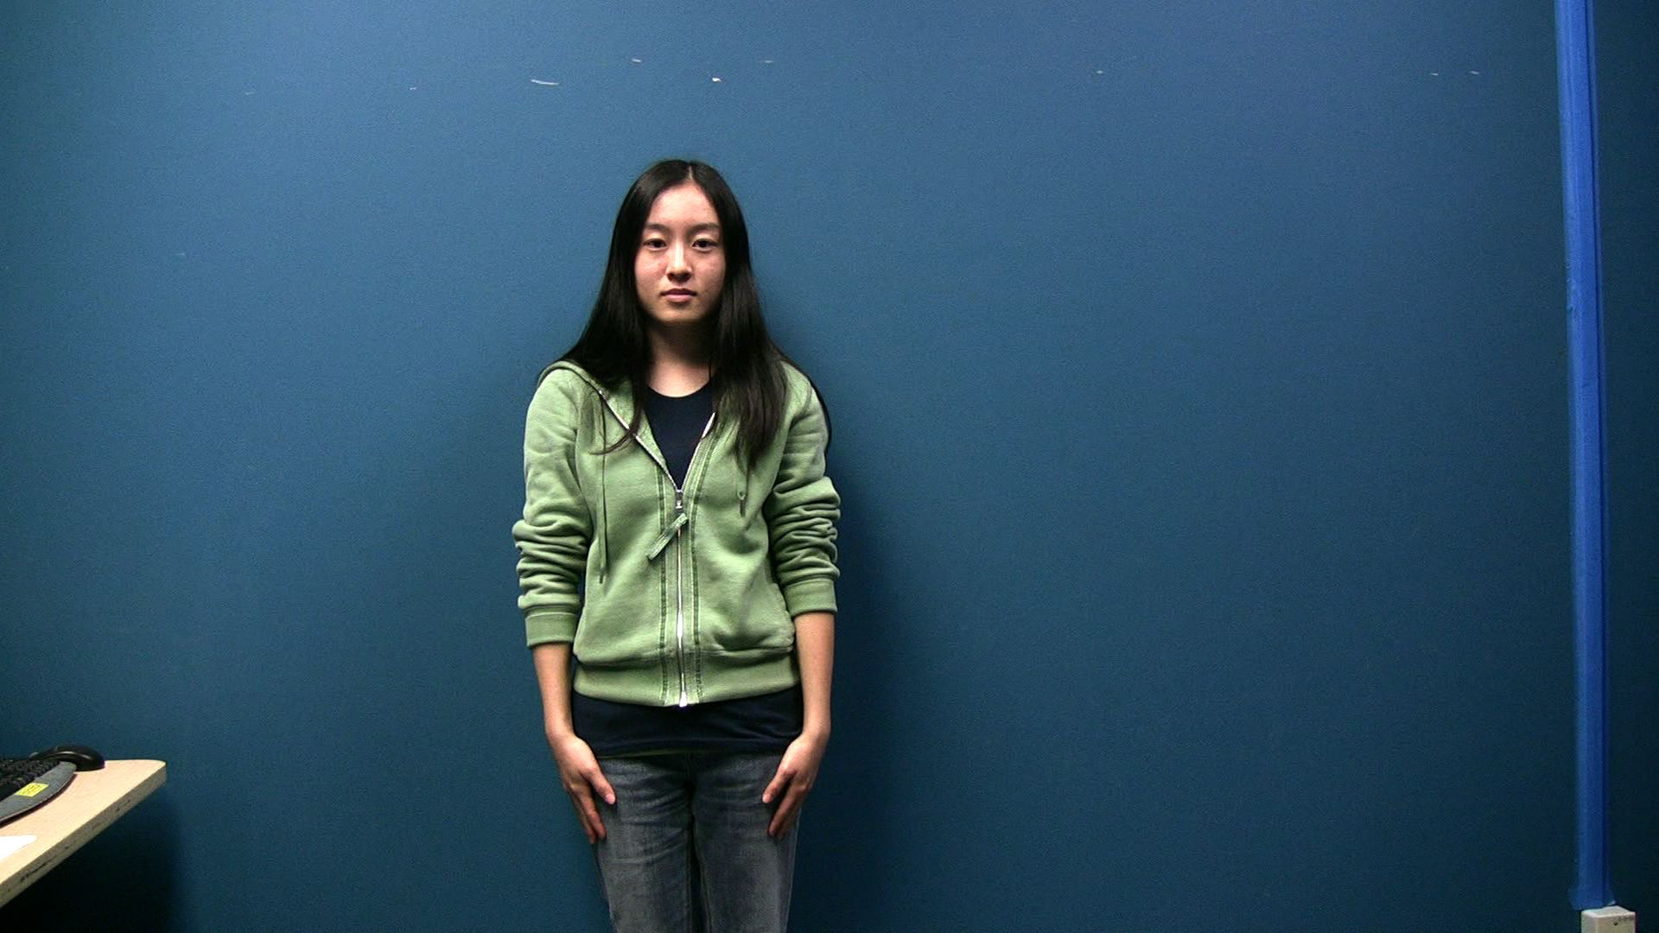
Watch
A sample movement. Each trial will contain 1 – 5 movements.

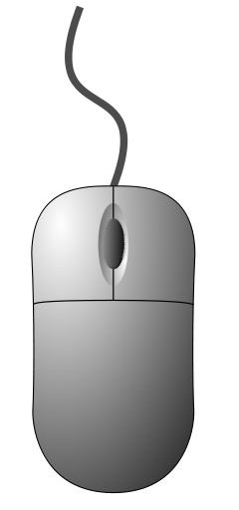
Please replicate the movements.
When prompted to replicate the movements, be sure to face the experimenter.
Go on
The experimenter will prompt you click the monitor with the mouse for the next trial.

